A000-ASIA-Indus Valley-Miniature Bowl-Mehrgarh-Terracotta-3000 BCE

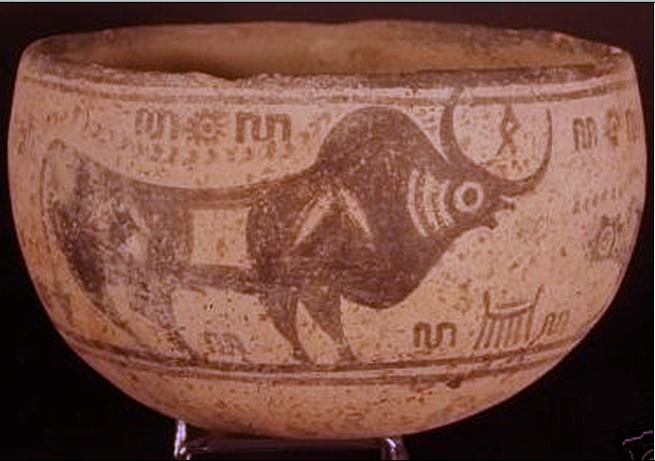

Fig. 1. Indus Valley-Figurine-Mehrgarh-Terracotta-3000 BCE

**Case no.: 3**

**Accession Number: A….**

**Formal Label:** Indus valley-Figurine-Mehrgarh-Terracotta-3000 BCE

**Display Description:**

This Mohenjo-daro Pot flat base this appears to be unique in design. It has a flat base and a globular body. The subject is of a Horned Zebu bull being stalked by two tiger type animals, which are at the front and back of the Bull. The Jar is very rare and has writing around it, which we cannot decipher. The motifs are encased within two bands top and bottom. This may have been a funerary object with no perceived domestic use. It was not uncommon to have a large number of miniature pots buried with the body symbolic of religious ritual symbols to help the deceased in the journey to reincarnation.

**LC Classification:** PK119

**Date or Time Horizon:** 3000-2500 BCE

**Geographical Area:** Mehrgarh

**Map, GPS coordinates: 29.38716 67.60955; 29º23'13.77" N 67º36'34.37" E**

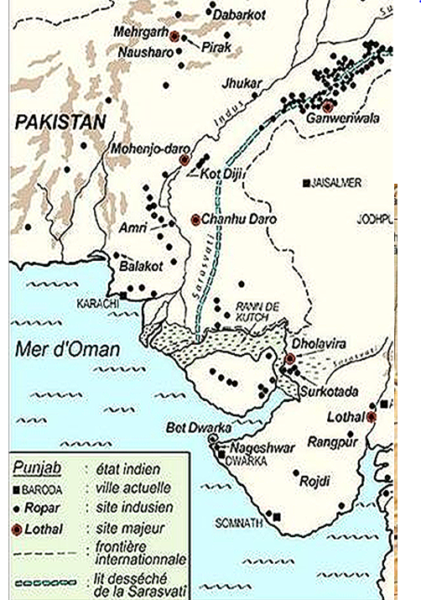

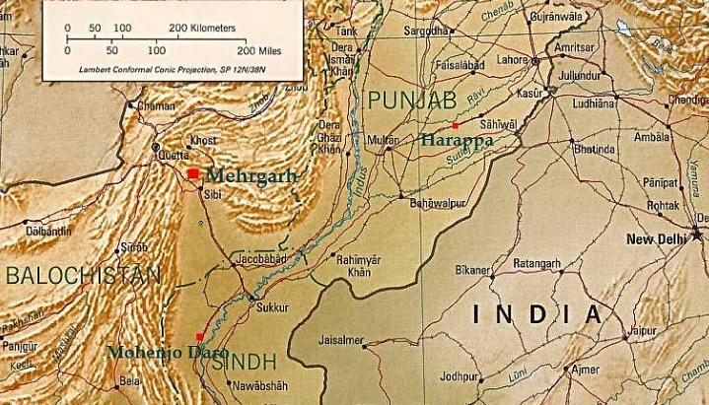

Figs. 2-3. Megharh in its geographical setting.

**Cultural Affiliation:** Indus

**Medium:** is red colored terracotta with the motifs encased within two bands top and bottom of the bowl.

**Dimensions:** H 74.66 mm; 119.83 mm top opening

**Weight:** 333 gm.

**Condition: original**

**Provenance:** Old European Collection

**Discussion:**

Mehrgarh was one of the oldest of the Indus Valley Civilization cities that was established ca 3000 BCE in the Indus and Ghaggar-Hakra river valleys (which is now Pakistan) and also northwest India and parts of Afghanistan and Turkmenistan. This Mehrgarh bowl has two symbolic Zebu bulls with curled horns, and a symbol between the horns signifying the locality it is destined to protect. It seems that the bulls are being led by a rope, separated by a palm tree. An Ibex is painted in black around the circumference with lines and scales below. This whole wheel-made bowl has a red slip painted over it internally and externally before the tan color and black design were painted over.

**References:**